Game Design Document

Fill up the following document

1. Write the title of your project.

Ninja fight

1. What is the goal of the game?

We have to choose any chrecter and fight with oponents to win

1. Write a brief story of your game.

In this game we have to play the game , in the game we will have to fight with the enimies and win

1. Which are the playing characters of this game?

* Playing characters are the ones who respond to the user based on the input from the user.
* Cars, monkeys, dinos, wizards, etc., are the playing characters in the game.

|  |  |  |
| --- | --- | --- |
| Number | Character Name | What can this character do? |
| 1 | monkey | He can jump very high |
| 2 | Ninja | He has special powes |
| 3 | godzilla | He can become small |
| 4 | mummy | He can go under the  ground |
| 5 |  |  |
| 6 |  |  |
| 7 |  |  |
| 8 |  |  |

1. Which are the Non-Playing Characters of this game?

* Non-Playing characters are the ones that don't have an action or behavior when the user interacts with the game.
* Hurdles, stones, bananas, coins, etc., are non-playing characters in the game.

|  |  |  |
| --- | --- | --- |
| Number | Character Name | What can this character do? |
| 1 | Poison air | Some toxic air will come and give damage |
| 2 | Lava rain | Lava will fall and give damage |
| 3 |  |  |
| 4 |  |  |
| 5 |  |  |
| 6 |  |  |
| 7 |  |  |
| 8 |  |  |

Draw your imagination of this game. What does this game look like?

* Draw the game either on your computer or on paper.
* Add images of the game scenes to show each of the playing and non-playing characters at least once.

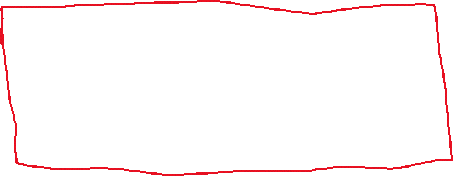

How do you plan to make your game engaging?



Having scores,fights ,obsticals this is a multiplayer game ,you can choose your charecters and play with them.

